T-Shirt Orders submitted after September 21, 2020 may not be completed by event day.

Registrant Name: __________________________________________________________________
Add Registrant: ___________________________ Add Registrant: _______________________________
Add Registrant: ___________________________ Add Registrant: ________________________________
Add Registrant: __________________________ Add Registrant: ________________________________

Address: _________________________________________________________________________________
Phone Number: ___________________________________________________________________________
Email Address: ____________________________________________________________________________
Size/Quantity: Small € ______ Medium € ______ Large € _____ XL € _____ 2XL € _____

Donation: __________________ On Behalf Of:________________________________________
T- Shirts are $20.00 a piece
On-Site Pick-Up: #213 Greenhill Ave., Ste. B Wilmington, DE 19805

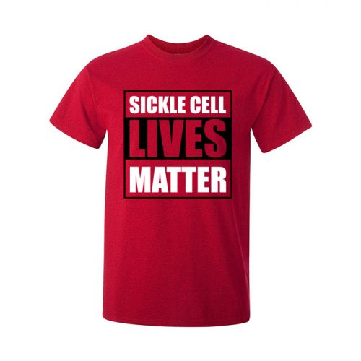
Total: ___________ + $10.00 for shipping & handling

Payment Methods:

PayPal: contact@tovacommunityhealth.org

Send Check: C/O Tova Community Health/SCD Virtual Run/Walk
PO Box 9663 I Wilmington, DE 19809 I EFax 888-433-4219

For more information please contact our TOVA. Please mail/email completed registration form and payment date to contact@tovacommunityhealth.org/events or call 302-429-5870 ext. 120. Refunds are not allowed for this event.

With Appreciation,

Dr. Nina
Executive Director

TOVA Community Health I 501c(3) Organization

HELP US PROMOTE the sickle cell virtual run/walk through social media and word of mouth
PLACE:
Brandywine Park or a local park near you.

DESCRIPTION
We are in this fight together for Sickle Cell, but we can't be together now. Stay connected to the TOVA by supporting the James Faucett III Sickle Cell Virtual 5K Run/Walk.
We invite you to still participate where you are by running or walking for 20 minutes during the weekend of September 26-27, 2020.
All proceeds support TOVA Community Health, which provides comprehensive holistic and compassionate care and outreach to individuals with complex medical conditions like sickle cell anemia/trait.
We invite everyone -- runners and walkers, old and young -- to participate and support the TOVA community! Register today, donate on behalf of a sickle cell warrior and spread the word to your friends and family!

EVENT QUESTIONS
Email or call: contact@tovacommunityhealth.org or call 302-429-5870 ext. 120.

