**Sickle Cell Lives MatterTM T-Shirt Order Form**

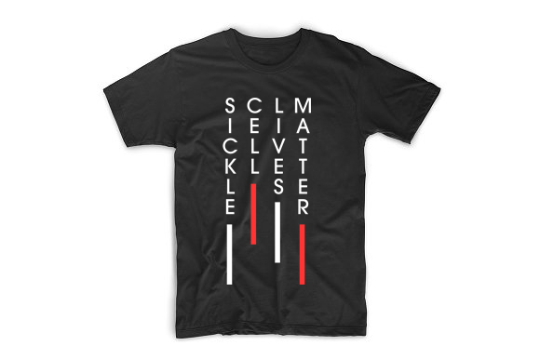

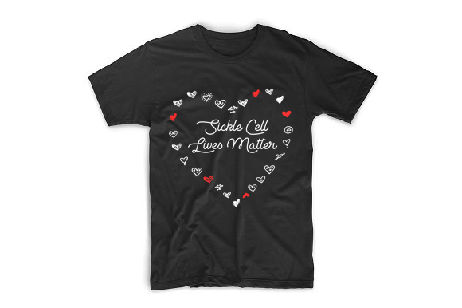

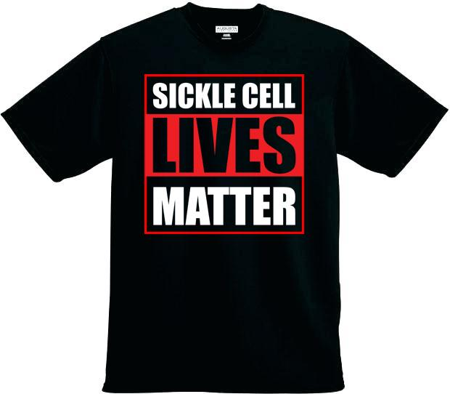



**Horizontal**

**Vertical**

**Red**

**Black**

**All Shirts are 100% Cotton!**

**T-Shirts: $20.00**

**plus**

**Shipping & Handling: $10.00 Fee per Chapter Order**

**Order Forms are Due**

**By**

**May 18, 2020**

**Total Amount Enclosed: $**

|  |  |  |  |  |  |  |
| --- | --- | --- | --- | --- | --- | --- |
| **Please indicate number of each Size** | **Small** | **Medium** | **Large** | **X-Large** | **XX-Large** | **Totals** |
| Sickle Cell Lives Matter  Red |  |  |  |  |  |  |
| Sickle Cell Lives Matter  Black |  |  |  |  |  |  |
| Sickle Cell Lives Matter Horizontal |  |  |  |  |  |  |
| Sickle Cell Lives Matter Vertical |  |  |  |  |  |  |
| **Total Number of Shirts Ordered** | | | | | |  |

|  |  |
| --- | --- |
| **Chapter** |  |
| **Street Address:** |  |
| **City, State, Zip** |  |
| **Phone** |  |
| **Fax** |  |
| **Order Date** |  |
| Make **Checks Payable** to: **TOVA Community Health, Inc**. | |

|  |  |
| --- | --- |
| **Card Number** |  |
| **Expiration Date** |  |
| **Total Amount to Charge** |  |

**10%** of proceeds help benefit **SCDAA** Chapters

**Questions Call:** 888-433-4219

**E Fax Order Form:** 888-433-4219

Sickle Cell Lives Matter

**www.tovacommunityhealth.org**

**Tova Community Health, Inc.** P.O. Box 9663 Wilmington, DE 19809