|  |  |
| --- | --- |
| **NAME** |  |
| **ADDRESS** |  |
| **CITY/STATE/ZIP** |  |
| **PHONE** |  |
| **FAX** |  |
| **CONTACT** |  |
| **ORDER DATE** |  |

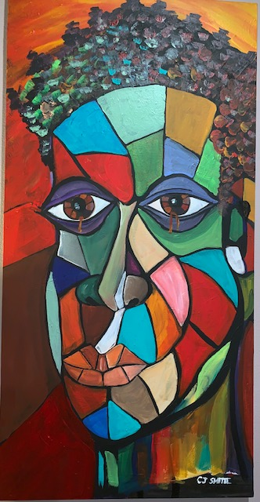

*Your proceeds help benefit the TOVA Fund which helps support the needs of our families during financial hardship for optimal health and wellness.*

Limited Edition ‘*In the Struggle I Rise’* Print: $75.00

plus

Shipping & Handling: $10.00

|  |  |  |  |
| --- | --- | --- | --- |
| Item | Quantity | Unit Price | Amount |
|
| **‘In the Struggle I Rise’ Print** |  |  |  |
|  |  | Total |  |

|  |  |
| --- | --- |
| **PAYMENT TYPE** |  |
| **TOTAL AMOUNT TO BE CHARGED** |  |
| **CARD NUMBER** |  |
| **EXPIRATION DATE** |  |